# Uros Stojanovic 0404/2019 DZ3 EA

# Q&A

U ovom primeru imamo realan model u kome cujemo zvuk koji se od izvora prostire u svim pravcima i do nas stize i direktnom linijom i reflektovano. Pri refleksiji signal gubi odredjene delove na razlicitim frekvencama u zavisnosti od karakteristike podloge. Uticaj refleksije se moze umanjiti poboljsanjem usmerenosti izvora i prijemnika i odabirom podloge sa najvecim apsorpcionim karakteristikama.

# Grafici

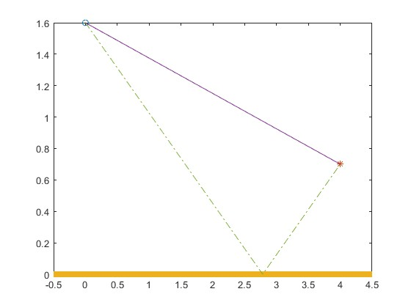

Prikaz izvora, prijemnika, podloge i putanja kojima se krece signal

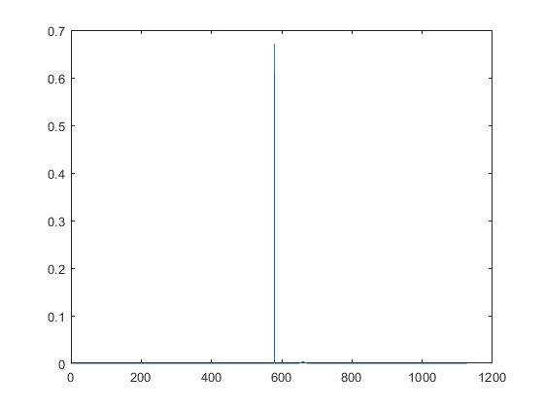

Signal na prijemu

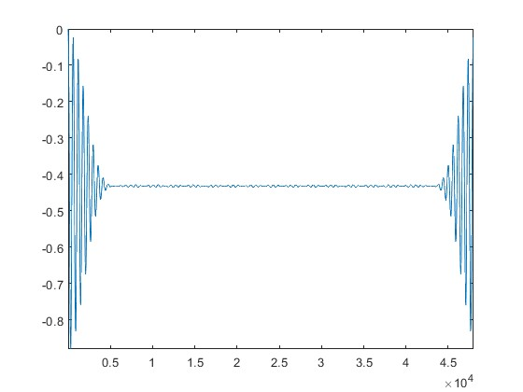

Impulsni odziv na prijemu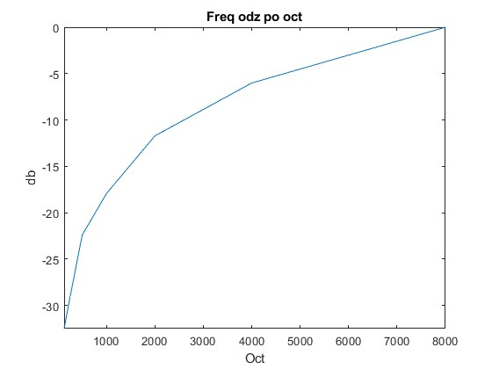

Frekvencijski odziv po oktavama

# KOD

clear all;

close all;

clc;

fs=48000;

c=340;

r0=1.206;

bbbb=404;

hz=2-mod(bbbb,10)/10;

hm=1.5-1.4*mod(bbbb,8)/7;

h=hm+hz;

dh=abs(hm-hz);

xm=3+mod(bbbb,5)/4;

L=sqrt(xm*xm+h*h);

Teta=asin(h/L);

Uz=1+mod(bbbb,4);

Um=4-mod(bbbb,4);

D=sqrt(xm*xm+dh*dh);

omega=asin(xm/D);

switch Uz

case 1

koefZr=1;

koefZd=1;

case 2

koefZr=cos(2*pi-Teta);

koefZd=cos(1.5*pi+omega);

case 3

koefZr=(1+cos(2*pi-Teta))/2;

koefZd=(1+cos(1.5*pi+omega))/2;

case 4

koefZr=(1+3*cos(2*pi-Teta))/4;

koefZd=(1+3*cos(1.5*pi+omega))/4;

end

switch Um

case 1

koefPr=1;

koefPd=1;

case 2

koefPr=cos(pi+Teta);

koefPd=cos(pi/2 + omega);

case 3

koefPr=(1+cos(pi+Teta))/2;

koefPd=(1+cos(pi/2 + omega))/2;

case 4

koefPr=(1+3*cos(pi+Teta))/4;

koefPd=(1+3*cos(pi/2 + omega))/4;

end

M=1+mod(bbbb,3);

switch M

case 1

m=[0.01 0.01 0.01 0.02 0.02 0.02 0.05 0.05 0.05];

case 2

m=[0.18 0.18 0.12 0.1 0.09 0.08 0.07 0.07 0.07];

case 3

m=[0.46 0.46 0.93 1.0 1.0 1.0 1.0 1.0 1.0];

end

f=[0 125 250 500 1000 2000 4000 8000 24000]/fs *2;

m=sqrt(1-m);

filt=fir2(20,f,m);

figure, plot(0,hz,"o")

hold on

plot(xm, hm, "*")

plot([-0.5 xm+0.5],[0 0],"LineWidth",6)

plot([0 xm],[hz hm])

plot([0 (xm*hz/(hz+hm)) xm], [hz 0 hm],"-.")

hold off

x=zeros(1,round(8*fs/c));%8=2*max(xm)

x(1,round(L*fs/c))=x(1,round(L*fs/c))+sqrt(r0*c/(4*pi))*abs(koefPr*koefZr/L);

x=filter(filt,1,x);

x(1,round(D*fs/c))=x(1,round(D*fs/c))+sqrt(r0*c/(4*pi))*abs(koefPd*koefZd/D);

X(1,:)=fft(x(1,:));

os=1:round(fs/(length(X)-1)):fs;

figure, plot(os,20*log10(abs(X(1:length(os)))/max(abs(X)))), ylim tight, xlim tight

figure, plot(x)

fl=125;

flo = 88.388;

freq=[];

sk=[];

while flo<=12000

freq(end+1)=flo;

flo=flo*2;

sk(end+1)=fl;

fl=fl*2;

end

for i = 1:length(freq)-1

Y(i, 1) = sum(abs(X(1, round(8*freq(i)/c):round(8*freq(i+1)/c))).^2);

end

figure, plot(sk(1:end-1),20*log10(Y/max(abs(Y)))), title("Freq odz po oct"), xlim tight, ylim tight, ylabel("db"), xlabel("Oct");